Quiz

Q1. a) List down the Traditional POS Categories **(2)**

b) Assign Penn parts of speech tags (as per Table 1) to all the words in the following two sentences using the notation word/POS: **(4)**

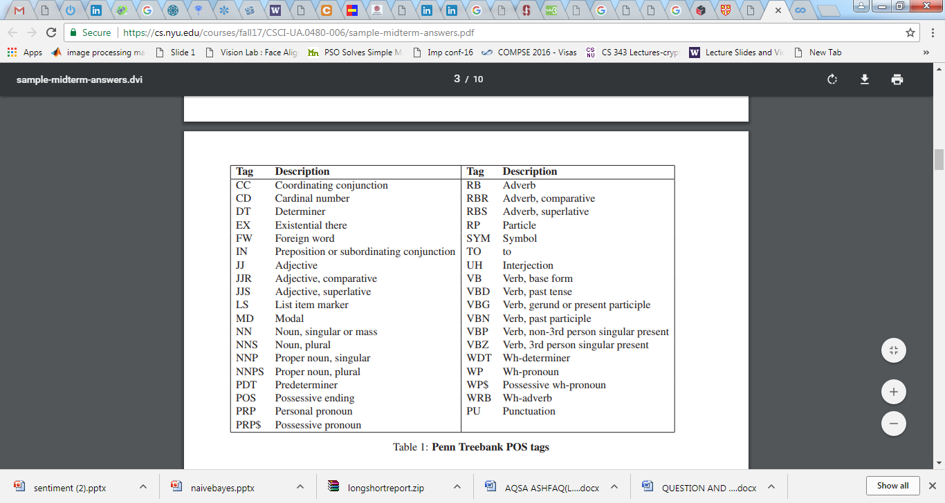

1. John and Mary bought a refrigerator with three doors .
2. It was purchased from a very small store near their house

Q.2 Draw a Phrase Structure Tree representing one parse of the following sentence. Make a list of the phrase structure rules that you are assuming. **(3)**

"John and Mary bought a refrigerator with three doors"

Q3 a) list down the Parameters of vector space models **(1)**

b) Discus the Three Perspectives on word Meaning **(3)**

c) How Homonymy causes for NLP application **(2)**

a. John/NNP and/CC Mary/NNP bought/VBD a/DT refrigerator/NN with/IN three/CD doors/NNS ./PU

b. It/PRP was/VBD purchased/VBN from/IN a/DT very/RB small/JJ store/NN near/IN their/PRP$ house/NN ./PU

